**BASIC SIGNAL OPERATIONS**

**LAB # 07**



**Spring 2023**

**CSE301L Signals & Systems Lab**

Submitted by: **Ali Asghar**

Registration No. : **21PWCSE2059**

Class Section: **C**

“On my honor, as student of University of Engineering and Technology, I have neither given nor received unauthorized assistance on this academic work.”

Submitted to:

**Engr. Sumayyea Salahuddin**

Date:

**May 25, 2023**

**Department of Computer Systems Engineering**

**University of Engineering and Technology, Peshawar**

## Lab Objective(s):

Objectives of this Lab are;

* Generating unit impulse and unit step sequences
* Basic signal operations

## Task # 01:

Using ones function; plot the signum sequence over interval ‐10≤n≤10. It can be defined as:

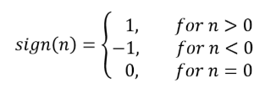

**Problem Analysis:**

Impulse signals are important type of signals in SS.

**Algorithm:**

* Take in the signal parameters
* Plot the signal

**Code:**

**Output / Graphs / Plots / Results:**

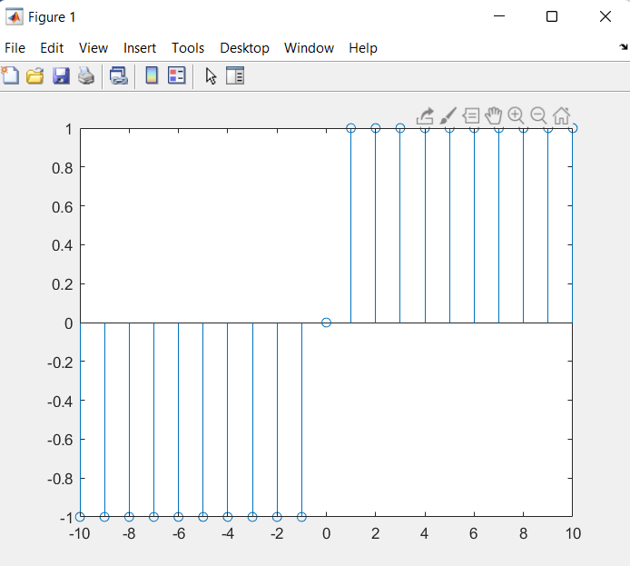

**Discussion and Conclusion:**

We can produce signum sequence in MATLAB.

## Task # 02:

Prove the following:



**Problem Analysis:**

Unit Impulse signal is a difference of unit step and delayed unit step signal. We prove that,

**Algorithm:**

* Take in unit step signal.
* Take in delayed unit step signal.
* Subtract both signals.
* Plot all three (including resultant) signals

**Code:**

**Output / Graphs / Plots / Results:**

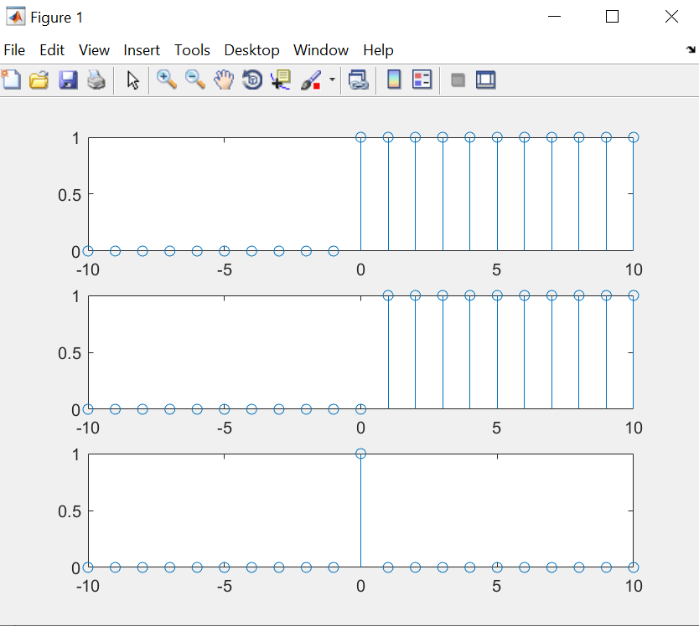

**Discussion and Conclusion:**

Hence L.H.S == R.H.S

## Task # 03:

Delay the original signal given in above example by 1 sec. Plot both the delayed & original signal on the same figure.

**Problem Analysis:**

Delaying a signal is important for certain signal operations.

**Algorithm:**

* Take in the signal
* Delay the signal
* Plot the signal

**Code:**

**Output / Graphs / Plots / Results:**

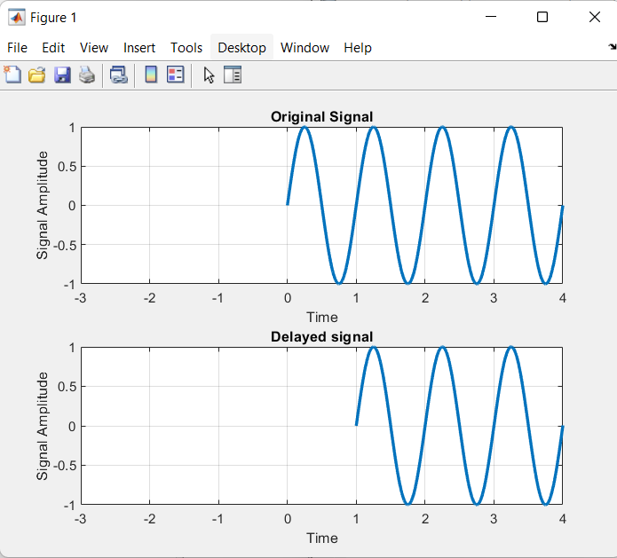

**Discussion and Conclusion:**

Thus we can delay a signal in MATLAB.

## Task # 04:

Flip the following signal:



Plot the original signal as well as the flipped one in the same figure.

**Problem Analysis:**

Signal flipping is sometimes desired in MATLAB.

**Algorithm:**

* Take in the signal
* Flip the signal
* Plot both signals

**Code:**

**Output / Graphs / Plots / Results:**

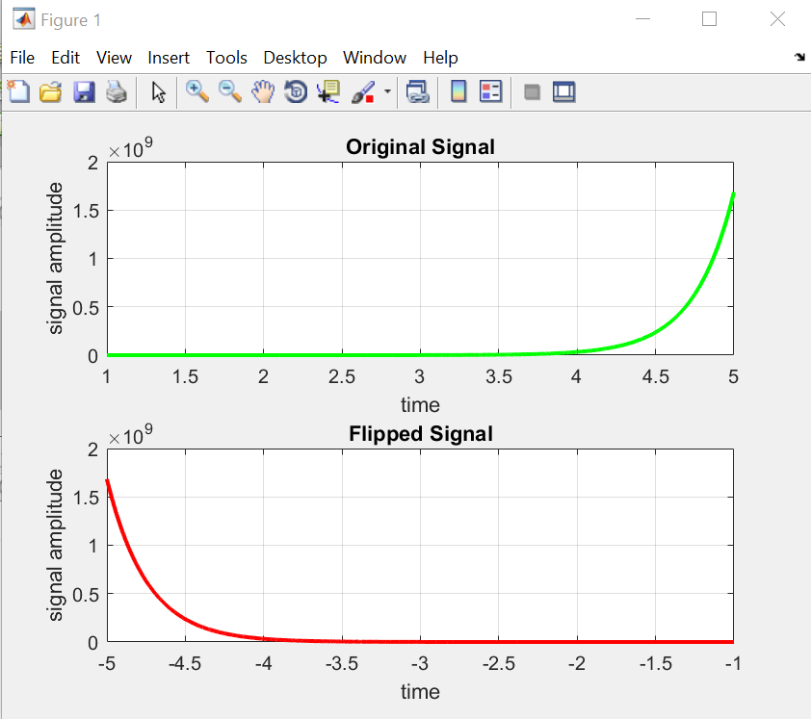

**Discussion and Conclusion:**

Thus we can flip a signal in MATLAB.

## Task # 05:

Flip the following signal:

x[n]= 2δ[n]+ 5δ[n‐1] + 8δ[n‐2] + 4δ[n‐3] + 3δ[n‐4]

Plot the original signal as well as the flipped one in the same figure.

**Problem Analysis:**

Signal inversion or flipping is an important signal operation.

**Algorithm:**

* Take in the original signal.
* Flip the original signal.
* Plot both signals

**Code:**

**Output / Graphs / Plots / Results:**

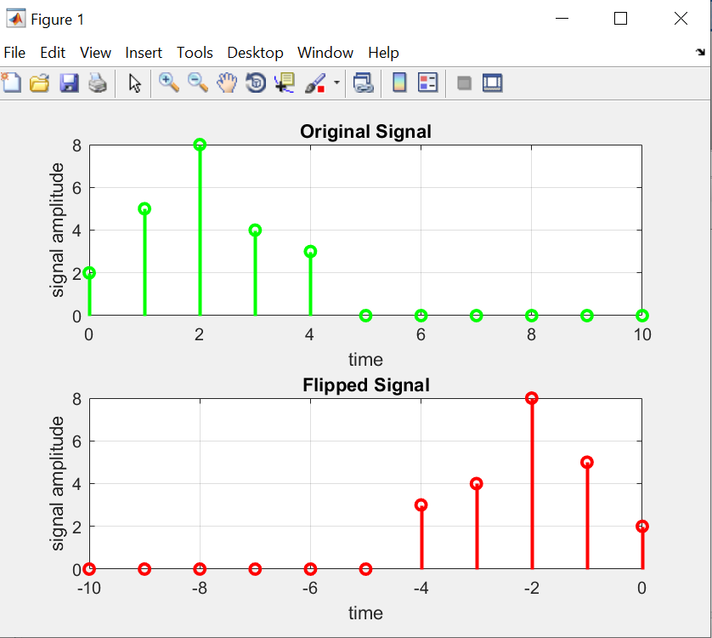

**Discussion and Conclusion:**

Thus we can flip a signal in MATLAB.

## Task # 06:

Scale the continuous‐time sinusoid used in signal shifting example by a factor of 2.

**Problem Analysis:**

Amplitude scaling is necessary for signal operations. Here we perform amplitude scaling

**Algorithm:**

* Take in the original signal.
* Scale its amplitude by 2.
* Plot both signals.

**Code:**

**Output / Graphs / Plots / Results:**

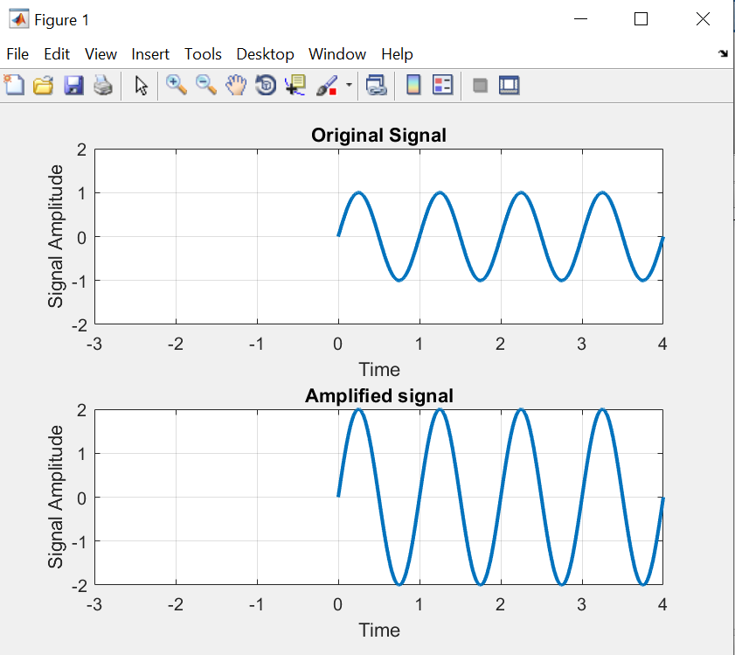

**Discussion and Conclusion:**

Thus we can shift a signal in MATLAB.

## Task # 07:

Use interp command in the above program to interpolate (up‐sample) the signal by a factor of 2.

**Problem Analysis:**

Interpolation is necessary for signal operations. We perform interpolation.

**Algorithm:**

* Take in the signal.
* Interpolate it.
* Plot the signal.

**Code:**

**Output / Graphs / Plots / Results:**

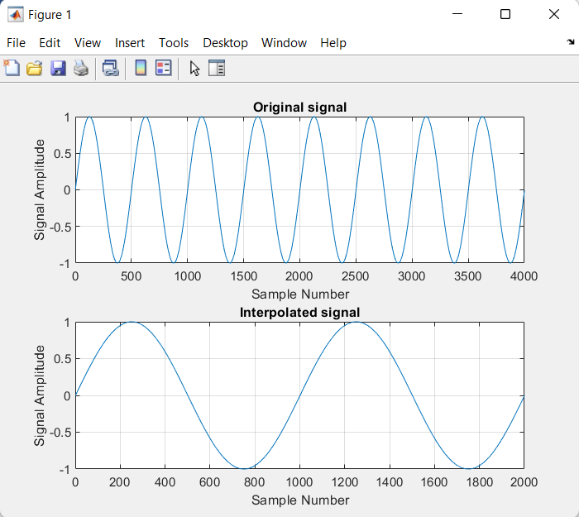

**Discussion and Conclusion:**

Thus we can interpolate a signal in MATLAB.

**Conclusion:**

**Basic Signal Operations:**

There are different operations that can be performed on the signals such as time shifting, flipping, amplitude scaling, time scaling, amplitude clipping, and signal replication.

**Signal Shifting**

In Signals & System theory, we perform signal shifting operation on signal in time domain by adding or subtracting a number to from independent variable, let’s say t.

* If to is positive, then signal is advanced (Will shift towards left)
* If to is negative, then signal is delayed (Will shift towards right)

In MATLAB, we perform signal shifting operation on signal in time domain as described above but the results are opposite.

* If to is positive, then signal is delayed (Will shift towards right)
* If to is negative, then signal is advanced (Will shift towards left)

**Signal Flipping**

Signal Flipping means time reversal of a signal. We can achieve it by multiplying -1 with the independent variable. In MATLAB, same procedure is followed as mentioned above.

**Amplitude scaling**

In SS Theory, we define amplitude scaling as multiplying a signal by a constant factor. In MATLAB, we can scale the amplitude of a signal by multiplying it by a constant.

**Time scaling**

In SS Theory, we define time scaling as multiplying independent variable of a signal by a constant factor. In MATLAB, we can perform time scaling on a signal by manipulating the time vector associated with the signal. The time vector represents the time instances at which the signal is sampled. By modifying the time vector, we can change the time scale of the signal.